Sam Lee

Sam Lee’s Team

CSC-131

4/22/2019

HW #5 – Use Case

Part I:

Diagram A: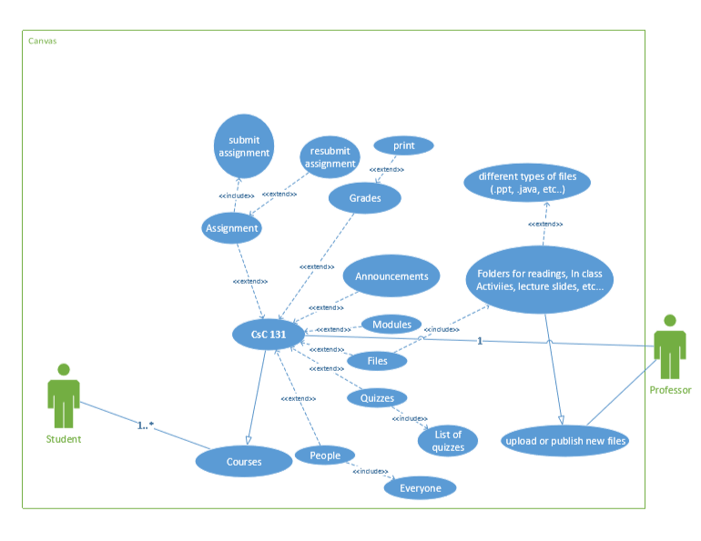

Diagram B: 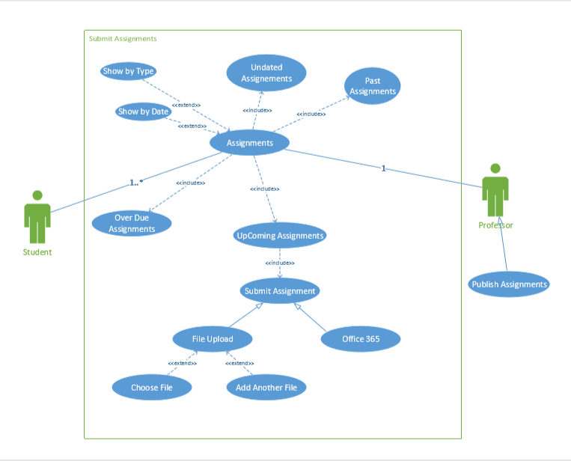

Part II: Use Case Scenario

Use Case Name: **Grades**

Actors: **Students, TA, Professor**

Stakeholders and Needs:

* Provides up to date grades published by either the TA or the professor
* Must have the title of the assignment graded along with the published grade
* Must have a total percentage or the course grade listed anywhere on top of the page

Preconditions:

* Course for which is grade is being viewed should be listed
* Name of the user aka student should be listed
* All the separate categories that contribute to the total grade should be included

Post Conditions:

* A tab for selecting the course grade that a student wants to view
* A tab for arranging how the student wants to view their grade. i.e. (by due date, title, module, or assignment group)
* Student should be notified to check their grade

Trigger:

Either the TA or Professor publishes a grade which the student wants to view, or a grade change occurs which the student wants to view.

Basic Flow:

1. A grade is published
2. The student is notified
3. The student checks the grade
4. If there is a mistake, an option to modify and change the grade will be implemented by the TA or the professor
5. The grade is updated
6. Student checks and verifies corrected grade

Extension:

* A button for “Show what-if scenario” as well as “revert to actual score”.
* A button to show all details for all the grades posted as well as close all details
* A button to print the listed grades

Part III: Interaction Design Principles

**SAC:**

**Simplicity**: Canvas is simple and user friendly as a user can access a specific thing under a specific tab when navigating. For instance, if a user wants to access lecture notes under a course, they will be under Files tab and in the lecture slides folder. 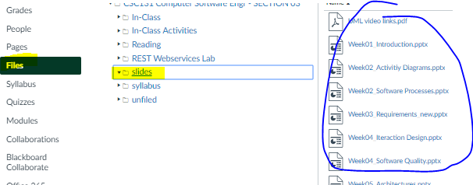

**Accessibility**: Canvas is accessible in terms that a user can use keyboard shortcuts to navigate through canvas. A user can also use a screen reader which can allow a disabled person to see/hear the text on canvas.

**Consistency**: The format of canvas is consistent as all the tabs are aligned and similar in shape and form. Also, the structure under each tab is the same for all the components. For example, if a user accesses the home tab under a course, they see many boxes with similar layout for the things they covered within each school week. See image below for further clarification.

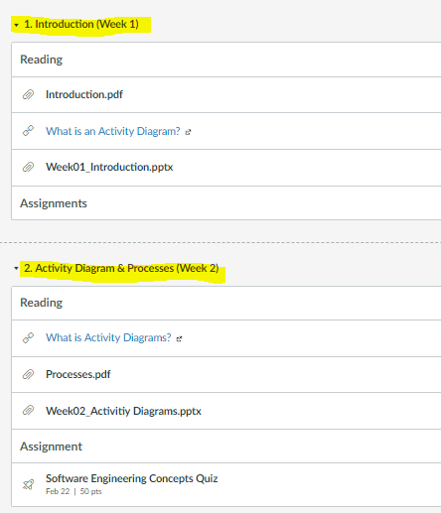

**CAP**:

**Contrast**: On canvas all the buttons appear green which pops out from the white background. For example, on the assignments tab there is a submit assignment button which stands out as shown in the image below.

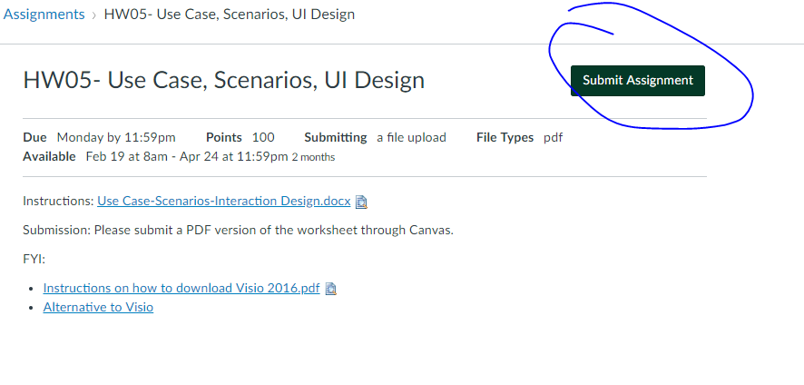

**Alignment**: A grid is used to portray grades on canvas where the assignment names, their due dates, and results for the assignments are shown in a lined-up manner, see image below.

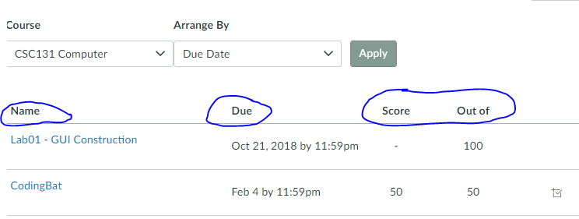

**Proximity**: As seen in the image below, when a certain tab is clicked, all the items in that group appear together. In the image below, when the tab Courses is selected, all the courses being taken appear together since they are related. 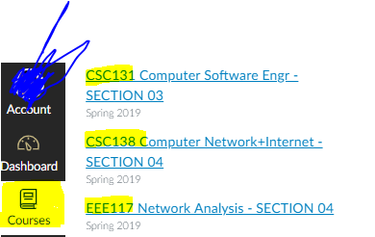

**FeVER:**

**Feedback**: Under the tab Grades, a student can evaluate their future grade by adding a temporary “What-if-scenario” grade. This in terms is acknowledging the user’s interaction with canvas by showing an output in accordance to the actions of the user’s input. The image below is an example of how this is done. 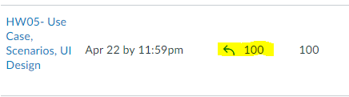

The inputted grade will result in a certain output grade above, but the user can click the blue arrow next to the input grade to revert-back to the original grade for the actual output grade as well. This is a controlled action by the user.

**Visibility**: A student or user of canvas can access files uploaded by another user or professor and download them. The file being downloaded shows its state hence better visibility for the user as to what canvas is doing. The image below shows a prominent operation which is visible for the user.

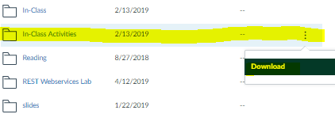

**Error Prevention**: Many error prevention methods are provided on canvas. One example is when a user logs into canvas. An error message is displayed if either the username or the password provided by the user is incorrect.

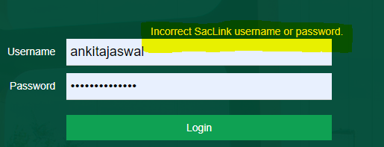

**Recovery**: A recovery method is displayed when a student goes to submit an assignment. There is an extension which allows to the user to resubmit the assignment if there is a user error. See image below for clarification.

